Fadly Sofyansyah
A11.2021.13477

*contoh CSS.html
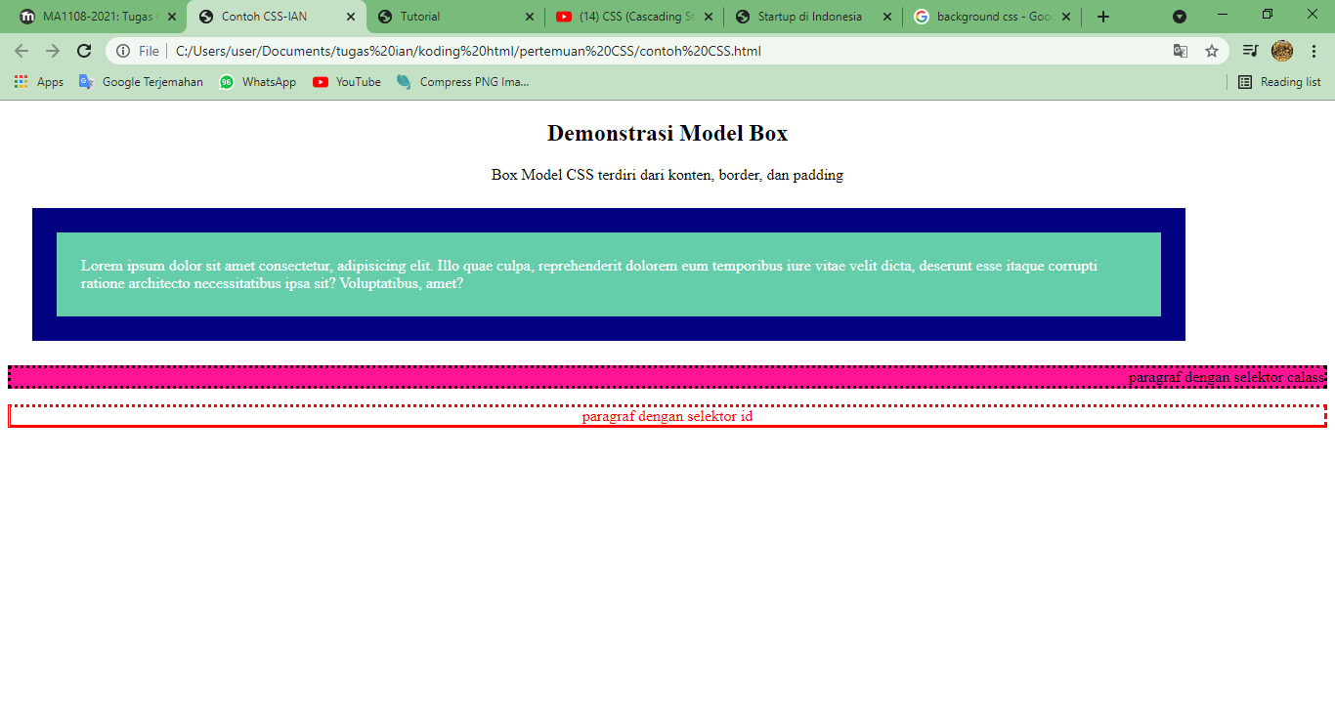
<!DOCTYPE html>
<html>
<head>
<title>Contoh CSS-IAN</title>
<link rel="stylesheet" type="text/css" href="style for contoh css (Eksternal).css">
<!--CSS eksternal-->
<style>
/* css internal */

</style>
</head>
<body>
<h2>Demonstrasi Model Box</h2>
<p>Box Model CSS terdiri dari konten, border, dan padding</p>
<div style="background-color: mediumaquamarine; color:white; width: 80%;">
<!--CSS Inline-->
Lorem ipsum dolor sit amet consectetur, adipisicing elit. Illo quae culpa, reprehenderit dolorem eum temporibus iure vitae velit dicta, deserunt esse itaque corrupti ratione architecto necessitatibus ipsa sit? Voluptatibus, amet?
</div>
<p class="pc">paragraf dengan selektor calass</p>
<p id="pid">paragraf dengan selektor id</p>
</body>
</html>

CSS eksternal
div{
background-color: gold;
width: 300px;
/* lebar*/
padding: 25px;
/* ruang antara konten dan border*/
border: 25px solid navy;
/*garis antara padding dan margin - ukuran style - color */
margin: 25px;
}
.pc{
border-style: dotted;
text-align: right;
background-color: deeppink;

}
#pid{
border-style: dotted dashed solid double;
/* atas kanan bawah kiri*/
color: red;
}
h2,p{
text-align: center;*/
}

*Turorial.html
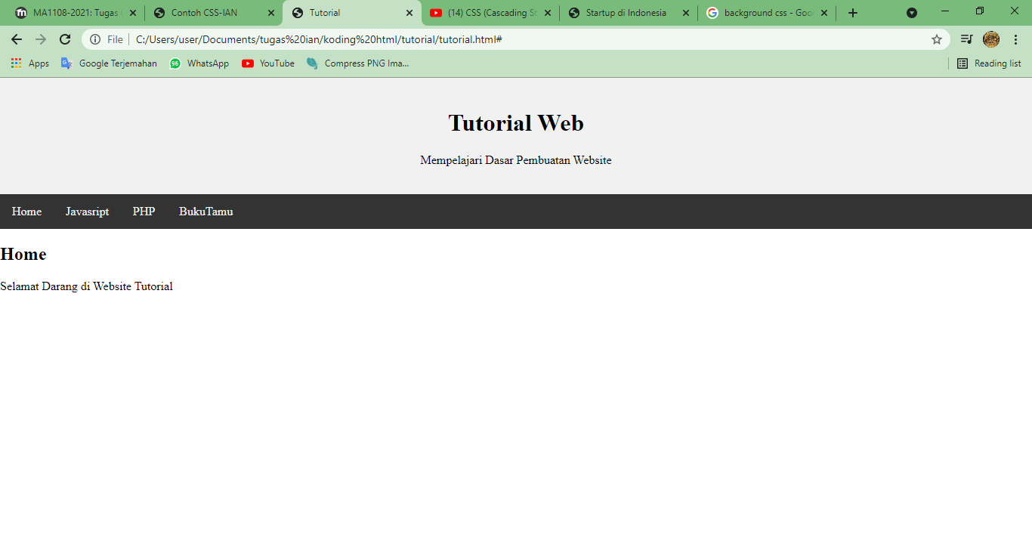
<!DOCTYPE html>
<html>
<head>
<title>Tutorial</title>
<meta charset="utf-8">
<meta name="viewpoint" content="width=device-width, initial scaled=1">
<!--untuk menyesuiakan tampilan terhadap layar pengguna-->
<style>
*{
box-sizing: border-box;
}
body{
margin: 0;
}
.header{
background-color: #f1f1f1;
padding: 20px;
text-align: center;
}
.topnav{
overflow: hidden;
background-color: #333;
}
.topnav a{
float: left;
display: block;
color: #f2f2f2;
text-align: center;
padding: 14px 16px;
text-decoration: none;
}
.topnav a:hover{
background-color: #ddd;
color: black;
}
</style>
</head>
<body>
<div class="header">
<h1>Tutorial Web</h1>
<p>Mempelajari Dasar Pembuatan Website</p>
</div>
<div class="topnav">
<a href="#">Home</a>
<a href="#">Javasript</a>
<a href="#">PHP</a>
<a href="#">BukuTamu</a>
</div>
<div class="row">
<div class="colum">
<h2>Home</h2>
<p>Selamat Darang di Website Tutorial</p>
</div>
</div>
</body>
</html>
*startup.html
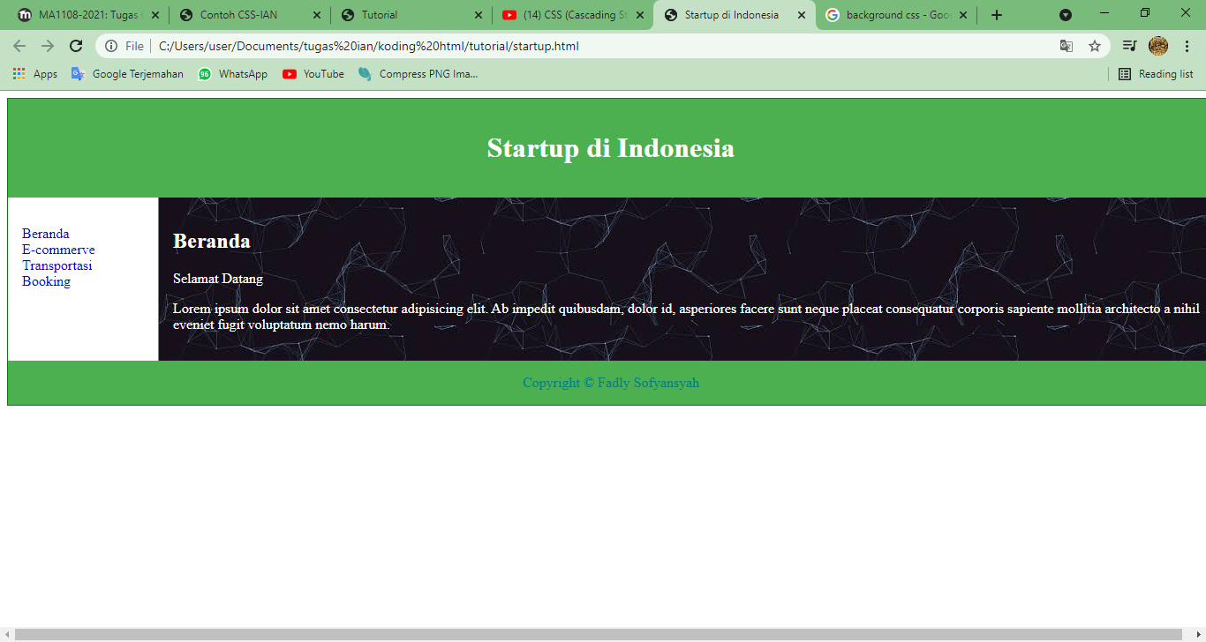
<!DOCTYPE html>
<html>
<head>
<title>Startup di Indonesia</title>
<meta charset="utf-8">
<meta name="viewpoint" content="width=device-width, initial scaled=1">
<link rel="stylesheet" type="text/css" href="style4startup.css">
<style>

</style>
</head>
<body>
<header>
<h1>Startup di Indonesia</h1>
</header>
<nav>
<ul>
<li><a href="#">Beranda</a></li>
<li><a href="#">E-commerve</a></li>
<li><a href="#">Transportasi</a></li>
<li><a href="#">Booking</a></li>
</ul>
</nav>
<article>
<h1>Beranda</h1>
<p>Selamat Datang</p>
<p>Lorem ipsum dolor sit amet consectetur adipisicing elit. Ab impedit quibusdam, dolor id, asperiores facere sunt neque placeat consequatur corporis sapiente mollitia architecto a nihil eveniet fugit voluptatum nemo harum.</p>
</article>
<footer style="color: teal;">
Copyright &copy; Fadly Sofyansyah
</footer>
</body>
</html>

Eksternal
body{
width: 100%;
border: 1px solid green;
}
header, footer{
padding: 1em;
color: white;
background-color: #4caf50;
text-align: center;
}
nav{
max-width: 160px;
padding: 1em;
margin: 0;
float: left;
}
nav ul{
list-style-type: none;
padding: 0%;
}
nav ul a{
text-decoration: none;
}
nav ul a:hover{
background-color: #4caf50;
color: white;
}
article{
margin-left: 170px;
border-left: 1px solid grey;
padding: 1em;
background-image: url(image/back.jpg);
color: white ;
}

